Polar Bears Offense – SF Revolution 2010

General principles
- Never clear up the middle of the field. Doing so clogs the primary lanes and risks collisions with in-cuts. Find the far sideline, clear quickly horizontally, and then progress up the field until you can cycle back into the flow of cutting.
- Always keep an active eye on the thrower when you cut. Pump-fakes are the universal signal to change directions and/or clear.
- Be mindful of holding the disc on either sideline. Upfield looks will be limited due to constraints in cutting space. Recognize and look to your dumps accordingly by stall 4.
- Hucks should be flat and thrown to cutters striking deep at an angle. Avoid hucks that float and allow multiple defenders to swarm under the disc.
- Run through poaches, engaging two defenders to guard you leaves a teammate wide open. Likewise, if your defender is looking to poach help, vocalize that you’re being poached and cut/clear away from your defender to increase the distance he/she will have to catch up to you.

Dumps
- Our dumps are universal for all 4 offensive sets (Banana, Maytag, Tower, and EZ). A successful team is one that can hit their dumps with 100% accuracy and completion.
- If there are no open throws by stall 4, turn and face entire torso toward the primary dump.
- Dumps should position themselves at least 10 yards away from the thrower. This will allow plenty of space to engage your dump defender as well as reducing the opportunity for them to poach in the throwing lanes.
- When the disc is in the middle of the field the dumps should position themselves at a 45 degree angle behind the thrower. Middle dump sets should use blow-by/dish passes. Step out with balance and deliver the disc to their chest.
- When the disc is on the sideline the dumps should line up even. The primary sideline dump should take two steps and expect a space pass throw backfield, otherwise a pump-fake will signal the upline look. Space passes to the primary dump move the disc quicker and gives the dump momentum to throw a continue pass to a swing cut. Give the swing pass/secondary dump an honest look before turning attention upfield.

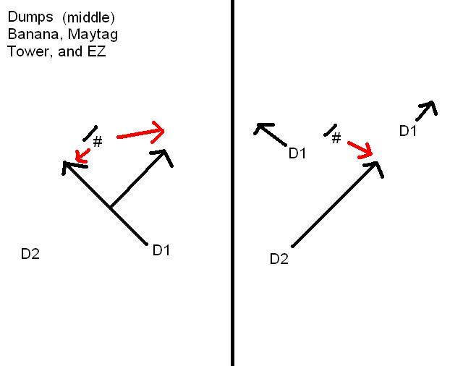
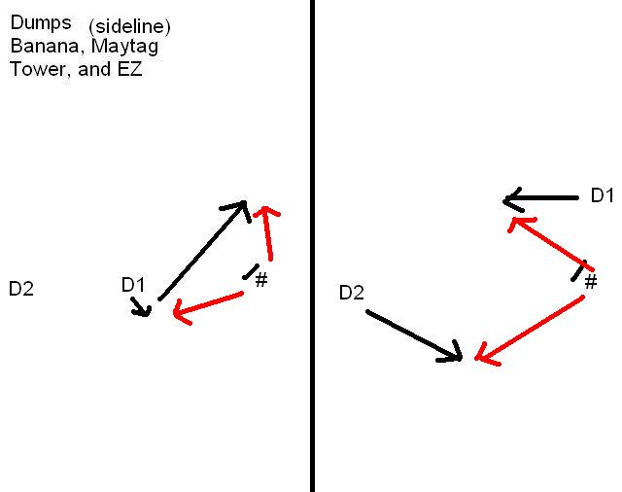

4-letter word system
- Both horizontal offenses (Banana and Maytag) will use the 4-letter word system to initiate cutter movement and offensive flow. Each letter represents a cutter in the ho-stack and the word is spelled from the view of the thrower. Numbers are then assigned after a letter to signify what type of cut the thrower wants (1 is open-side under, 2 is open-side deep, 3 is break-side under).
- Once the play is called out and the disc is tapped in the two active cutters immediately sprint to their designated cuts. The two non-active cutters clear to the closest of the two sidelines (if we’re in Banana) or the weak sideline (if we’re in Maytag).
- If the word is H-A-L-O then a common playcall will be “A2, L1”, engaging the two middle cutters. We will hit what’s open and let the offense flow from there.
- Always clear toward the weak sideline after cutting under while still keeping your eyes on the thrower for the break-mark look.

“Banana” - split-stack offense (disguised as a horizontal stack off a dead disc)
- Banana gives absolute priority to the middle two lanes. Those middle cutters have the freedom to attack anywhere in the 30-yard wide open area deep or under created by the two non-active cutters staying all the way on the sideline.
- Assuming the force is flick with the word still H-A-L-O, the “H” cutter is looking to give continuation cuts deep from the weak sideline. A pump-fake will let “H” know to plant and come under to attack the newly cleared middle lanes.
- The “O” cutter is looking to strike for the IO break when it’s clear no cuts are developing from the deep space in the middle two lanes. Occasionally the “O” cutter can cut deep for a break-mark huck if a strong thrower with momentum catches the disc. But realize if the huck does not go up then the “O” cutter must commit to cutting under either through the middle lanes or returning to the strong sideline.
- This offense allows for creativity attacking the break-side lanes in addition to our primary mindset of hucking deep to height/speed mismatches.

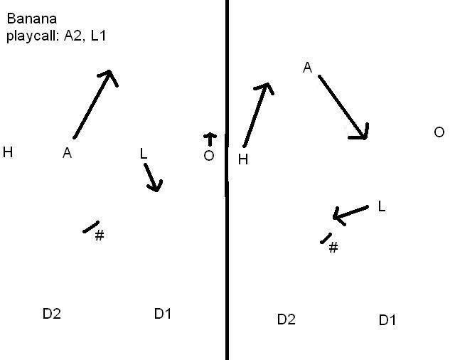

“Maytag” - flood/sidestack offense (disguised as a horizontal stack off a dead disc)
- Maytag assigns a strong and weak side cutting lane which depends on what sideline the defense is forcing.
- Assuming the force is again flick with the word being H-A-L-O, cutters “L” and “O” are standing in the strong side lane while “H” and “A” are on the weak side lane. Strong side cutters should be off set toward the middle of the field. Weak side cutters should be off set toward the weak sideline.
- A play call is crucial to start the Maytag offense from a dead disc. One cutter will be called deep, one under, and the two non-active cutters must clear horizontally all the way to weak sideline (where “H” should be positioned off a dead disc).
- Once in offensive free flow, the cuts should originate one at a time from the weak side.
- The mandatory progression of the cuts is open-side deep, open-side under, break-side clear. Pump-fakes will guide cutters through each cut.
- The flow for cutters against the flick force should resemble a clockwise diamond motion (and vice-versa, a counter-clockwise diamond motion against a backhand force).
- This offense is geared toward isolating individual cutters and giving them a 30-yard wide lane to outrun their defenders deep, then under, then break-side.
- Break-side looks will not be as crucial for advancing the disc since most throws will be open-side deep or open-side under.
- Again, run through poaches if you see a second defender guarding your cut. Likewise if you are not being guarded honestly, vocalize that you are open and distance yourself from your defender.

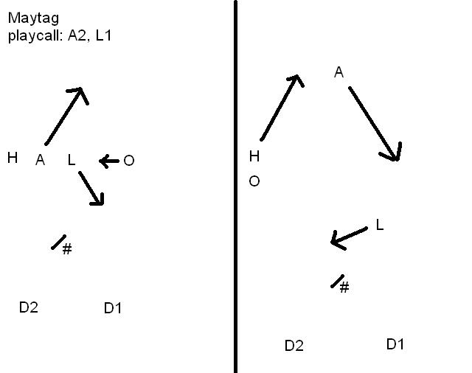

“Tower” – vertical offense
- 4 cutters in the stack, 1 person with the disc, 2 dumps.
- The front of the stack, our “Ace”, should position 10-15 yards away from the thrower and maintain eye contact at all times for quick break mark throws to space. The “Ace” has the option to offset a few yards toward the open-side for an easier break-mark throw, but must notice if his/her defender is poaching.
- The other 3 cutters in the stack should space 5 yards from each other as cuts and offensive flow should originate from the last-back in the stack (ideally cutting deep first, seeing a pump-fake, then coming under for longer gainers).
- After an unthrown in-cut clear hard toward the stack right behind the “Ace”.
- If your defender is poaching into the open-side lane, take a few steps toward the break lane and see where the defender really commits his/her attention (the open-side lane or you). Cut deep from there if your defender still does not return to guarding you.
- Be aware at all times how many dumps are behind the disc. Only 1 dump back means someone needs to fall back and fill. Having 3 dumps back means someone should fine the far cutting lane and strike deep. Dumps should embrace the mindset of cutting deep as the disc flows on either side of the field.
- Break-mark cuts from the back of the stack are encouraged. The follow up cut to an unthrown break-mark cut is to attack deep at an angle.
- Break-mark hucks, especially from the Ace, are an effective way to punish teams with undisciplined marks.
- Tower is the easiest offense to transition into EZ. Recognize accordingly, vocalize the “EZ” call, and back up in the stack to give the Ace/iso cutter space to work his/her defender.

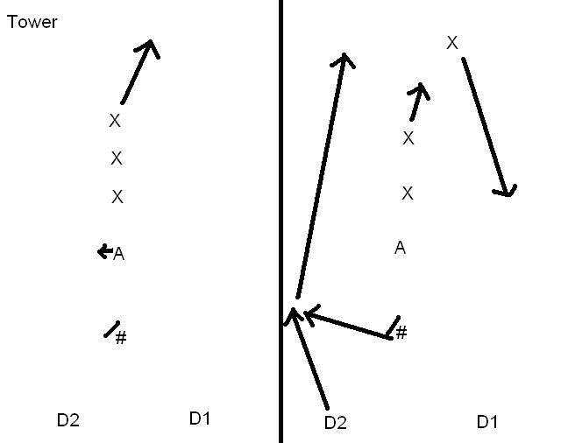

Endzone “EZ” offense
- “EZ” should be called 15 yards outside the endzone.
- When “EZ” is called on the field, do your part to echo the call to your teammates and the sidelines. Also remember to still clear up the sidelines and then into the back of the (vertical) stack.
- EZ will isolate the four players closest to the disc (one disc, two dumps, and one iso) and use break-mark looks, dump-swings, and give-go’s to advance the disc the remainder of the field for a goal.
- The three remaining players should converge into a vertical stack with a 5-10 yard buffer between the front of the stack and the iso cutter. Make sure your defender still engages you as a threat while you’re in the vertical stack to avoid poach D opportunities on the iso or dump.
- Off a dead disc, a break-mark space pass to the iso will be the first look. Otherwise look to the dump immediately to get the disc moving. Do not fall into the mindset of only looking at the iso cutter. The best way to initiate motion in our EZ offense is looking to the dumps. The dump set is universal for all 4 offenses for exactly this reason.
- Dancing and half-cuts are discouraged as they cause thrower confusion and don’t force the defender to commit to either direction. If your iso cuts have been looked off then clear up the sideline quickly and then into the back of the stack while calling out for a new iso cutter to fill.
- Give-go’s are the best way to foil dump defenders that are poaching in the lanes to prevent easy throws to the iso cutter. Attack the disc with confidence after you throw and challenge your defender to keep up with you.
- Remember that EZ requires patience and mutual chemistry between the thrower and the receiver. Hold yourself accountable to 100% throwing completion and goal conversion in the EZ offense. Whether you are one of the four active players or in the vertical stack waiting to cycle in and make the iso cut, everyone has a job to do to ensure the success of the EZ offense.

“A well-executed offense should look boring to the untrained eye.”

Rawr.
-808

